

Foundations of Programming

Lab Assignment No. : 03

PROBLEM STATEMENT:
Write a program in C to generate multiplication tables for a given number.
OBJECTIVES:
- To understand the use of looping statements in C.
- To generate multiplication tables using loops.
- To improve program logic and execution flow understanding.

THEORY:
Syntax for for loop example program
Syntax for while loop example program
Syntax for do while loop example program
ALGORITHM:
Step 1: Start.
Step 2: Declare variables
Step 3: Accept values from user
Step 4:
while(i<=10)
{
ans=n*i;
printf(“%d”,&ans);
i++;
}
Step 5: Stop.

Program:
#include <stdio.h>
int main()
{
int i=1,n,ans;
printf("Enter number: ");
scanf("%d",&n);

while(i<=10)
{
ans=n*i;
printf("%d\n",ans);
i++;
}
}

PLATFORM:
Linux

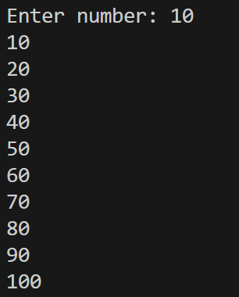
CONCLUSION:
Thus, the menu driven program in C successfully performs basic arithmetic operations using switch–case statements.

FAQs:
- Which loop is best suited for generating multiplication tables?
- What is the role of loop initialization?
- Difference between for loop, while loop and do while loop?
- Can a do–while loop be used to generate multiplication tables? Explain.
- Why is the do–while loop called an exit-controlled loop?

